

**Integration Functional**

**Design Specifications**

Version No. 1.1.13

September 12, 16

Author: *Integration COE Team*

**Document Control Information**

**Document Information <SOLUTION Architect>**

|  |  |
| --- | --- |
| **Name** |  |
| **Program Name** |  |
| **Author** |  |
| **Version** |  |
| **Status** |  |
| **CI Name** |  |
| **Document Owner** | Solution Architect - <Name> |

**Document Edit History <ALL Editors>**

|  |  |  |  |
| --- | --- | --- | --- |
| **Version** | Date | Description | Author |
| 0.1 |  |  |  |
| 0.2 |  |  |  |

**Contributors / Roles / Support / SME Resources / Audience (RACI Matrix) <Solution Architect>**

**<We need a list of SME and contributors, their contact information who has input to the design document**

**e.g. We need team members from Day9 Integration , Day9 Functional , HR Business , BA , iCOE Integration Architect , Solution Architect , Integration Lead>**

|  |  |  |  |  |
| --- | --- | --- | --- | --- |
| **Team** | Name | Role | RACI | Contact (Email / Phone) |
| Functional Support |  |  |  |  |
| Infrastructure Support |  |  |  |  |
| Solution Architect |  |  | Accountable |  |
| Integration Architect |  |  | Responsible |  |

**Approvals Sign off <<SOLUTION Architect & Approvals >**

**<Add the names of the individuals that need to give sign off to this document upon its completion.>**

|  |  |  |  |
| --- | --- | --- | --- |
| **Date** | **Role** | **Name** | **Signature** |
|  | Application owner | Rob Grajeda |  |
|  | BPL owner | Izabela Jelen |  |
|  | Solution Architect | ABC |  |
|  | BSM | Jeff Luther |  |

Table of Contents

1 Overview 3

1.1.1 Functional Overview 3

1.1.2 External/ Internal Document references 4

2 Business Objectives 5

2.1.1 Key objectives 5

2.1.2 Business success criteria 5

2.1.3 Support/Service Level Agreement (SLA) 5

2.1.4 Known Issues, Assumptions 6

2.1.5 Business Impact of Failure 7

3 Business Process Requirements 7

3.1 Overview 7

3.2 Overall Business Process Flow 8

3.3 Exception Business Process Flow 10

3.4 Scheduling Events 10

3.5 Business Events 11

3.6 Business Control Reports 12

3.7 Alerts & Notifications 12

3.8 Monitoring 13

3.9 Error/ Exception Handling 14

3.10 Non Functional Requirements 15

4 Data Requirements 16

4.1 Data interdependencies 16

4.2 Data flow diagram 16

4.3 Data Resiliency 17

4.4 Data Input / Output 18

4.5 Data Security Requirements 19

4.6 Eligibility Criteria 19

5 Functional Testing 19

5.1 Testing Overview 19

5.1.1 Unit Test Scenarios 19

5.1.2 Positive Acceptance Test Scenarios 20

5.1.3 Negative Acceptance Test Scenarios 20

# Overview

### Functional Overview

<Business Analysts>

<Provide high level business view about this integration. Explain how does this integration fits into larger strategy, overall goals at POD / or at major business function level.

If driving factor for the integration to align with Vendors/ Partners changes / strategy (or even to overcome limitations) please specify.

The section information also could be / should be pulled from the “project charter” and not recreated and new info—

This could be a link to Executive summary document created at Vendor or Partner level or even at POD / Business Process level or

Could be a link to similar section in BRR>

What function does the integration support?

Why are you doing the integration (support XX business process, support new vendor, etc.)

Similar to The Purpose function, but add info as to the function, business process, and any pain points that this integration solves for.

### External/ Internal Document references

<Please check Author Owner in following table>

Internal documents created and maintained by KO / Integration Partners (Day9)

External documents are created by SaaS providers, platform providers, 3rd party

|  |  |  |  |
| --- | --- | --- | --- |
| Item | Author / Owner | URL / Location | Version |
| Reference Architecture | EA / SA |  |  |
| POD Implementation Strategy | Business Process Owner |  |  |
| WorkDay Program Implementation Strategy | WorkDay Architect |  |  |
| ERD | Data Architect |  |  |
| WorkDay Canonical Model | Data Architect |  |  |
| WorkDay Ecosystem Diagram | EA |  |  |
| Testing Strategy | Test Lead |  |  |
| Business Process Map | Business Analyst |  |  |
| Configurations (need to discuss with BA ) | Business Analyst |  |  |

# Business Objectives

### Key objectives

<Business Analysts>

Provide details on Key Objectives, reasons, Purpose why we are implementing integration.

Provide high level gaps, new initiatives which are driving these objectives.

Provide details what business capabilities, functions will be supported, enabled through integrations.

Explain how this integration will resolve / mitigate current gaps and/or provide new capabilities etc.

As needed provide functional overview for this specific integration.

### Business success criteria

<Business Analysts>

<POD / Business Process Lead>

<Provide / enlist Success Criteria for Integration from Business perspective>

How / what will define integration is successful (or failed / partially Failed)? Ensure criteria is realistic and tangible

Guidelines: Ask probing questions to business / SME like

How will you measure success of this integration?

Is success measures in time, volume or at each record being integrated level?

Are there any conditions success criteria will be measured?

|  |  |
| --- | --- |
| Success Criteria | Conditions |
| Successful reporting of Paystubs in WD <Module1> | For all eligible employees |
|  |  |

### Support/Service Level Agreement (SLA)

<Business Analysts>

<Solution Architect>

<Support Lead>

Service level agreements / expectations

Based on success criteria and to ensure success criteria is mate find out -

Service Level Agreements / Expectations from support, platform systems / partners specific to this integrations

<Define SLA / Business expectations such as... excepted Cycle time to complete one instance of the integration , allowed retry attempts (In case of exceptions ), Allowable data quality / data Integrity before, after transaction etc.>

|  |  |  |
| --- | --- | --- |
| Expectation / SLA | SLA Type | Expected range / values |
| Maximum end to end allowable cycle time | Cycle Time | 10sec |
| Allowed Service Window | Availability | During business hours EST |
| Allowed Retry Attempts | Exception Management | 5 |
| Exception resolution allowable cycle time | Cycle Count | 1 day |
| Time Criticality |  | High, Medium, Low  For example   * High Integration is highly time critical & has to finish is specific day/time   Since Partner / vendor has very specific time window integration can be performed   * In case of error / exception its critical we need to resolve issues in timely / ASAP manner * Compare to other integration this integration has specific / high time criticality   009 INT is an example  INT100 – Employee verification letter |
| Business Importance |  | High, Medium, Low  <From Business perspective specific this integration is high / medium / Low important >  Not every integration is high  For example -  Payroll related integrations – High  Worker Address change – Medium (relative to Payroll integrations) |
| KO Support Standard | Support level  <LINK to KO Standard Support levels> | E.g. Platinum, Gold, Silver, Bronze  Based on the support standard picked, a support response time, resource allocation will be determined. |

### Known Issues, Assumptions

<Solution Architect>

<Business Analysts>

<Integration Architect>

<Support Lead>

<Mention issues specific to this integration only >

|  |  |  |  |  |
| --- | --- | --- | --- | --- |
| No. | Date | Assumption | Owner | Comments |
| 1 | 1/21/2016 | Availability of WorkDay tenant by date <> |  |  |
| 2 | 1/21/2016 | Availability of test data by Date <> |  |  |

|  |  |  |  |  |
| --- | --- | --- | --- | --- |
| No. | Date | Known issues | Owner | Criticality |
| 1 | 1/21/2016 | Issue1 |  |  |
| 2 | 1/21/2016 | Issue 2 |  |  |

### Business Impact of Failure

<Business Analysts>

<Solution Architect>

<Integration Architect>

<Support Lead>

This data is very helpful for designing solution which covers all impacted areas / to ensure design fits into larger solution .Also helpful to understand larger scope of an integration especially for end to end testing.

<In table below conduct impact analysis of this integration on people, process, systems and provide details –

effect on various Business Functions / Objectives/ Business processes , Users , groups , Support team - in case of full or Partial failure of this integration to drive requirements for transaction integrity and exception management>

|  |  |  |  |
| --- | --- | --- | --- |
| Impacted function or Business Process | Severity | Impact | Business Owner |
| BP1 | Low | Impact |  |
| Function1 | High | Impact 2 |  |
| Users / groups / region | High |  |  |

# Business Process Requirements

## Overview

## Overall Business Process Flow

<Business Analysts>

<POD / Business Process Lead>

<Information Architect>

<Business Process Flow is required when integrations are triggered directly from Business processes activities, user actions OR when Integration is an inbound (wrt KO platform, Systems)

<Possible link to model or link to Business Process section in BRR if already created>

Example

This is an example process diagram to the step level.  The final task (bottom right) "send data to the downstream systems".  The task is a link to the data flow diagram below (2. Manage Off-Boarding: Send data to direct systems.

Need decision on where models will be published and shared.

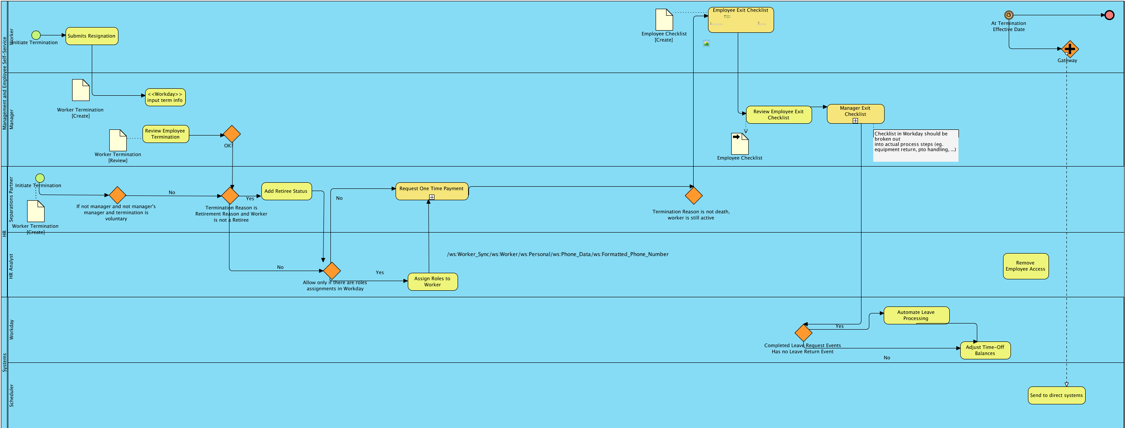

<Optional Downstream systems’ Process flow: As needed based on importance and complexity in end to end business process flow, downstream system processes may be included>

<Integration Architect>

<Business Analysts>

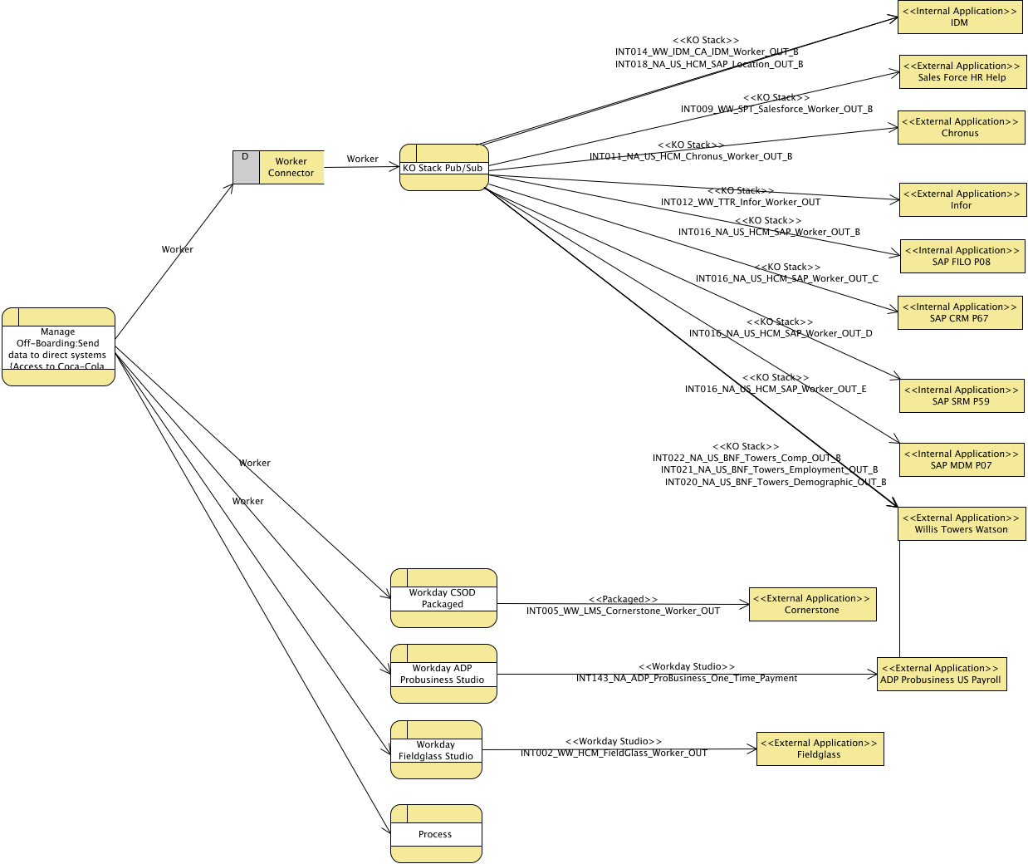

< **If integration is being triggered by more than one business process** then link to **all affected/ impacted business processes** in following table>

<If support / exception process is different than normal process, need to include exception handling process too>

|  |  |  |  |  |  |  |
| --- | --- | --- | --- | --- | --- | --- |
| Process Level | Link to Process Model | | Process Name | Process Definition | Contributing Capabilities / Function | Business Process Owner |
| 1 | |  |  |  | Hiring |  |
| 2 | |  |  |  |  |  |

## Exception Business Process Flow

<Solution Architect><Integration Architect>

<Business Analyst>

<PO/ Business Process Lead>

<Integration Architect>

<Describe how proposed future State business function / Integration will be performed,

& provide details How it will address identified GAPs, issues, improve provide more functionalities.>

<LINK to BRR or Model>

<Self-reference link to Functional overview section in this document is also accepted >

## Scheduling Events

<Business Analyst>

<Solution Architect><Integration Architect>

<Support Lead>

<Notes from Initiation details>

<This section is mandatory for integrations trigged by Business events, Process activities, user actions, Change in data state/value. >

<Also mandatory for all inbound integrations/ transactions regardless of source system(s) e.g. SAP, ADP, IDM etc.>

**<NEED this information for each business process / trigger, activity which might start/initiate this integration>**

At high level describe of how, when, which method and what conditions integration can be initiated / started

Guidelines:

<How will this integration get triggered?

Can it be initiated by various methods, actions / triggers etc.?

It is possible in normal condition integration might get triggered by default scheduler but in case of exceptions, emergency – an alternative method (e.g., manually, or Start up utility) might be required to start the integration)

<Complete as applicable >

<In table below list various scheduled events and their configuration that might start the integration. Configuration needs to be very specific such as

Day/time, frequency (Current if available & Proposed new Freq.), criteria, duration configurations>

|  |  |  |  |
| --- | --- | --- | --- |
| Schedule Event Name | Frequency | Time | Condition |
| Event1 | Daily | 12.00am | Only on business days |
|  |  |  |  |
|  |  |  |  |
|  |  |  |  |
|  |  |  |  |

## Business Events

<Business Analyst>

<Complete as applicable >

If integration is initiated based on user actions, messages received, activity completed in business process or state of data changed, we need to complete this section.

In following table enlist Source systems (Modules, Services), business Events, user actions, and change in data's state/value which will start / initiate this integration.

**<NEED this information for each possible business event (such as business process / trigger, activity, user action) which might trigger / initiate this integration>**

|  |  |  |  |  |
| --- | --- | --- | --- | --- |
| Business Event Name | Event Type | Triggering Source  Activity , Trigger , User Action | Source business process | Additional condition(s) |
| One-time Payment approved | User Action – | Worker Payment information saved | <Link to Business Process / specific activity > |  |
|  |  |  |  |  |
|  |  |  |  |  |
|  |  |  |  |  |
|  |  |  |  |  |

## Business Control Reports

<Business Analysts><Supporting Lead>

<Solution Architect> <Integration Architect>

<Optional -In following table provide requirements / needs for Business Control Reports. These reports ensures transaction integrity and business process/ Integration completeness –- These reports can be used to ensure integration was successfully completed/ or not and can be used for Business or IT as a troubleshooting tool

>

| Requirements for Business Control Reports | | | |
| --- | --- | --- | --- |
| *Report Name* | Req. No | Report Requirement | Importance /Priority |
| ***<Report Name>*** | R123 | Definition of control reports which can test & ensure integrity for this integration after execution.  For example – Worker Demographics report in BW can ensure how many worker’s information was successfully updated and which workers information was not in SAP P18. | H |
|  |  |  |  |
|  |  |  |  |
|  |  |  |  |

## Alerts & Notifications

<Solution Architect>

< Requirements regarding need for interchange Acknowledgement message from partner, vendor & transform level verification etc.>

|  |  |  |  |
| --- | --- | --- | --- |
| Target System / Module | Acknowledge Type | Required fields | Link to Sample |
| ADP | File Received | <Filename> <Date Time>  <Link To XML ,Link to Entity> |  |
| ADP | File Processed | <Filename> <Processed Date Time>  <Link To XML ,Link to Entity> |  |
| ADP | Record Processed | <Filename> <Record ID > <Correlation ID> |  |
| SFDC | Message | Request received  <Request ID><Correlation ID><Timestamp> |  |
| ADP | Email | Reconciliation File Created  <LINK to File Location><Partner ID> |  |

## Monitoring

<Business Analysts>

<Needs for Business Activity Monitoring – specifically what business data / conditions such as Error code, Error type , user action , integration flow steps completed , integration thresholds needs to be monitored - provide information FOR THIS SPECIFIC INTEGRATIONS ONLY>

(DO NOT provide details on Platforms, KO Stack, WD provides already monitors / provide details out of box)

<ICOE will provide a standard reference document and sample monitoring dashboards for all supported platforms describing Out of Box/ default monitoring capabilities>

<May be link to “Splunk Monitoring Requirements” document filled for this specific integration>

<Additional details may be needed such as >

<Link to Request Process to enable monitoring - especially if request process is already defined and need to request to add this integration to enable / start monitoring>

|  |  |  |  |  |  |
| --- | --- | --- | --- | --- | --- |
| Monitoring Req. ID | Process Name/ trigger / Event Schedule Activity Name | Conditions / Thresholds to Monitor | Information Source System / Platform | Business Fields / Date-time to monitor | Roles / Users |
| 1 |  |  |  |  |  |
| 2 |  |  |  |  |  |

## Error/ Exception Handling

<Solution Architect>

<Business Analysts>

< Specific requirements related to Business exception, retry needs, functional req. from support, and

Requirement to understand need for transaction integrity.

In the event of any exceptions / error during the execution of this integration,

* We need to know whether support team / business team should resume transaction or should restart the transaction. What are the conditions for restart Vs resume? (for example during integration execution if all records failed to transform - we need to restart the entire transaction )
* Further we need to know – BEFORE we restart / resume transaction is there any need to restore previous state of data or Systems. If yes please elaborate.

E.g. ATM banking scenario – ATM machine were not able to dispatch $20 bill due to some mechanical failure in dispatcher, to ensure transaction integrity - ATM machine should revert transaction and credit $20 back to the account and notify user.

Similarly if integration failed in middle of transformation for example, are there any needs to ensure transaction integrity and revert any changes in upstream or downstream systems before retry/resumption?

<DO NOT provide system or platform level exceptions here, SA / IA will derive / provide those in later sections based on business exceptions/ transaction integrity needs>

| Requirements for Error / Exception handling | | | |
| --- | --- | --- | --- |
| *Category* | Catalog Number | Requirement – Exception / Actions needed | Importance /Priority |
| ***Business Exception*** | WCFBE1 | If file got corrupted during transformation  Retry the transaction  Action: 1: Manually re-submit worker daily change file | H |
| ***Business Exception*** | BE143 | Mapping failed due to incorrect source data  Action: Correct source data in source system <System name> and resubmit the transaction manually | M |
| ***Data Integrity*** | D222 | Mule Soft failed to transfer complete Worker Out daily file to specified Ax Way folder   1. Mule Soft needs to verify whether entire file has been transferred successfully 2. If Ax Way raised FTP error , then delete incomplete file from Ax Way folder and attempt to recreate file | H |
|  |  |  |  |

## Non Functional Requirements

<Solution Architect>

<Business Analysts>

<Integration Architect>

|  |  |  |  |  |
| --- | --- | --- | --- | --- |
| No. | Requirements | Details | Importance / Priority | Impact  If requirement not mate |
| 1 | Integration Performance | Acceptable ranges <END to END integration performance needs >  (Mainly required for Synchronous integrations or one with Solicit Request / Response ) |  |  |
| 2 | Response Time for entire batch | Acceptable ranges |  |  |
| 3 | Payload Size & throughput requirements (Scalability) | Avg. / Max size of batch ,  Each record size , length etc. |  |  |
| 4 | Response time for each record in batch | Acceptable ranges |  |  |
| 5 | Reliability | FIFO , De-Duplication identification of incoming message , need for guaranteed delivery , |  |  |
| 6 | Availability | Time window , High Availability needs |  |  |
| 7 | Scalability | Auto-Scale needs – MAX - peak load / sizing (Avg. / MAX ) |  |  |

# Data Requirements

## Data interdependencies

<Information Architect>-

<Business Analyst>

<Solution Architect>

This section is more than one data entities are involved in integration and they are interdepended.

< Provide Internal / external data dependencies for sequencing / scheduling & Data aggregation requirements>

<Example >



## Data flow diagram

<Integration Architect>

<Link to Model –Data flow diagram for this integration>

Data flow diagram illustrates Entity / data movement, data manipulation steps such as Aggregation, dis-assembly / encryption or validation agnostics to systems / platform boundaries

Example

The integration data flow depicts the flow (and transformation) of data within the integration.  The data entities used by this integration are identified (see Common Data Model below diagram 7).  The integration specific ERD is depicted in the next diagram and provides the link between the common data model and the vendor specific data models.

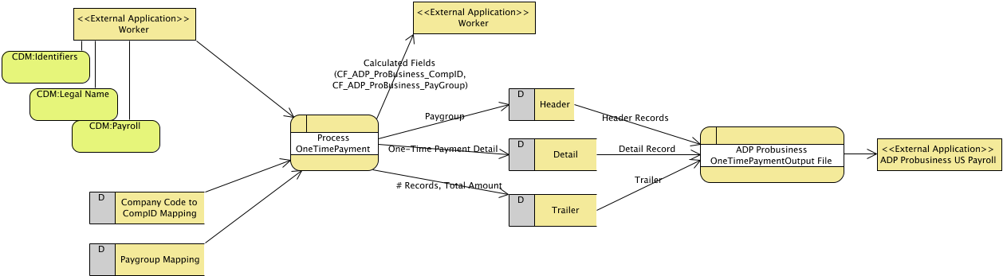

## Data Resiliency

<Solution Architect><Business Analyst>

Reason: this is the “how” and not the “what”, so this would be part of the design and not requirements.

We need to know what are the requirements to save inbound/messages to recover, retry transactions. We also need to know what should do if we get duplicate messages from partner/vendors.

Do we need to persist inbound / outbound data in case of exceptions/failures? How long data / message needs to be Saved/persisted? Need to encrypt it? How to find and discard duplicate messages? Alerts / Auditing needs for duplicate messages...

<Input / Out Data fields, Can source resent data in case of failure, does transaction need to restart / resume after exception >

Important for message based integrations

<Support needs requirements specifying needs for persistence, retry, and restart integration transaction >

Example: INT084

|  |  |
| --- | --- |
| Persistence | No requirement to persist the transaction, Maximus will persist the data |
| Audit | There is not a requirement to save the transaction but a report giving the employee, date, and time sent to the State of Georgia. The Audit data will be store a Maximus for 1 year. |
| On Error | Resend the file from the Source |
| On Update | Correct data in Source and resend |
| On Delete | N/A as deletes are not allowed by the State of Georgia. Data is keep indefinitely by State of Georgia. |

## Data Input / Output

<Data Architect> <Business Analyst>

<Integration Architect>

<Solution Architect>

Input entities with fields

For example for Worker daily out integration provide a link to connector out data model, since it will be and input the an integration INT016

<LINK to Data Model>

Output entities with fields

<Link to data Model>

Example

INPUT Entities Output Entities

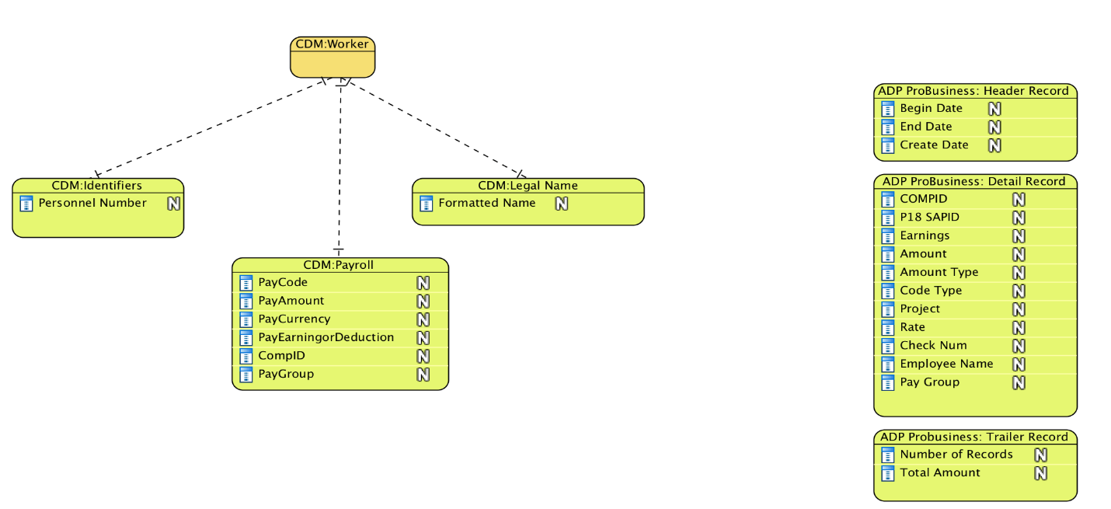

## Data Security Requirements

PI

SPI

## Eligibility Criteria

<Business Analyst>

<Solution Architect>

Provide eligibility / filter criteria for each input / output as applicable

In table give below list

Input entities eligibility criteria, grouping, order rules

Output entities eligibility criteria, grouping, order rules

Conditions, Eligibility criteria evaluations ((i.e. Special Populations, Contingent Workers, Active, Inactive, Retired, Withdrawn, Valid Invoices))

|  |  |  |  |
| --- | --- | --- | --- |
| Eligibility criteria | Input / Output Entity / Field Name | Conditions with Values / Ranges | Applicable Operation / Comments / Rules |
|  |  |  | For Insert/ Update / Delete operation |
|  |  |  |  |
|  |  |  |  |
|  |  |  |  |
|  |  |  |  |

# Functional Testing

## Testing Overview

<Need to provide an example of testing overview>

### Unit Test Scenarios

|  |  |  |
| --- | --- | --- |
| **#** | **High level Test Scenario** | **Scope** |
|  |  |  |
|  |  |  |
|  |  |  |
|  |  |  |

### Positive Acceptance Test Scenarios

|  |  |  |  |  |  |
| --- | --- | --- | --- | --- | --- |
| **#** | **High level Test Scenario** | **Reference to Req. ID**  **/ Catalog ID** | **Scope** | **Expected results** | **Link to test cases** |
|  |  |  |  |  |  |
|  |  |  |  |  |  |
|  |  |  |  |  |  |
|  |  |  |  |  |  |

### Negative Acceptance Test Scenarios

|  |  |  |  |  |  |
| --- | --- | --- | --- | --- | --- |
| **#** | **High level Test Scenario** | **Reference to Exception Req. ID**  **/ Catalog ID** | **Scope** | **Expected results** | **Link to test cases** |
|  |  |  |  |  |  |
|  |  |  |  |  |  |
|  |  |  |  |  |  |
|  |  |  |  |  |  |

Make sure to include following test scenarios and test cases

|  |
| --- |
| Test Scenarios to Cover - Alerts & Notifications (Only in PROD ) |
| Test Scenarios to Cover - Instrumentation (Logging , Notification , Monitoring ) |
| Test Scenarios to cover Business Success Criteria |
| End to End to test Scenarios - Including Downstream systems |
| Test Scenarios to cover Support , escalation processes (in case on exceptions ) |